**How to run gr-MRI/COSI Spectrometer?**

* Open a Terminal: ***Strg + Alt + T***
* Navigate to the folder where gr-MRI source code is saved: ***cd gnuradio-mri/mr-scripts/***
* Open a iPython Console: type ***ipython***
* Execute the gr-MRI/COSI Spectrometer application: ***run FID_GUI.py***
* A GUI like that should pop up:

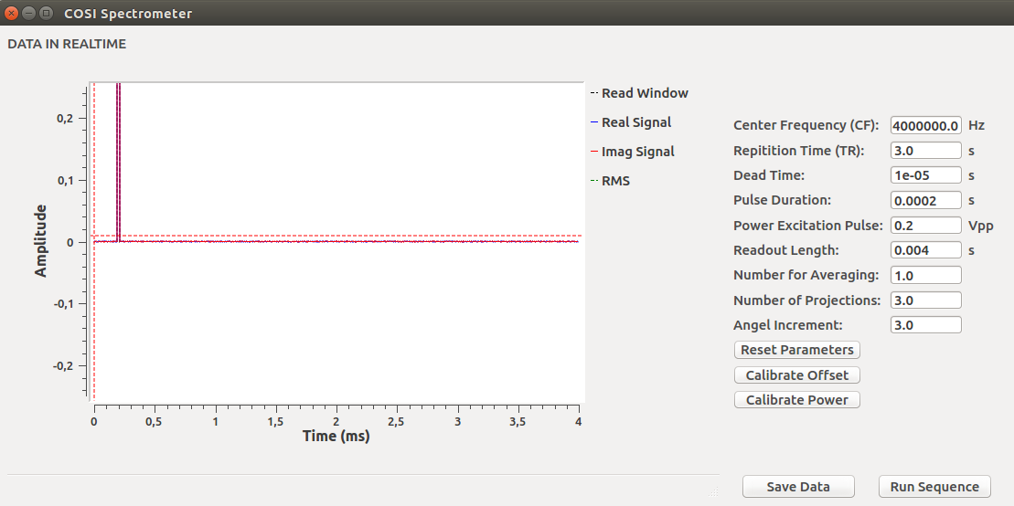

The Spectrometer GUI shows the data received by the USRP1 board in real-time (left side) and an editable list with the current parameter settings of the experiment. The text-fields can be used to edit/change the value of each parameter. The initial parameter values are stored in the FID_config.txt file. These initial values are also reloaded when pressing the ***Reset Parameters*** button. Pressing the buttons ***Calibrate Offset*** and ***Calibrate Power*** starts the offset and power calibrate functions implemented by Grissom/Hasselwander respectively (for more information have a look into their paper). Pressing the ***Run Sequence*** button initiates the acquisition of an FID/Sequence. The acquired data is stored in a local variable and can be saved in a text file via the ***save data*** button. Repeating the FID/sequence experiment will overwrite the data in the local variable.

**Clicking the mouse-wheel** in the area of the graph opens a menu. The entry **Number of Points** allows to

The whole gr-MRI/COSI Spectrometer application consists of the following python files:

* **FID_flowgraph.py**: defines the functionality of the GNU Radio flowgraph of the Spectrometer
* **Spectrometer_GUI.py**: defines the GUI of the application (text-fields, buttons,….)
* **FID_GUI.py**: provides functions to interface with the GNU Radio flowgraph, to start a sequence (FID() and scan())
* **Pulse_shape.py**: here the user defines shape of the RF excitation pulse (e.g. hard pulse, sinc pulse)